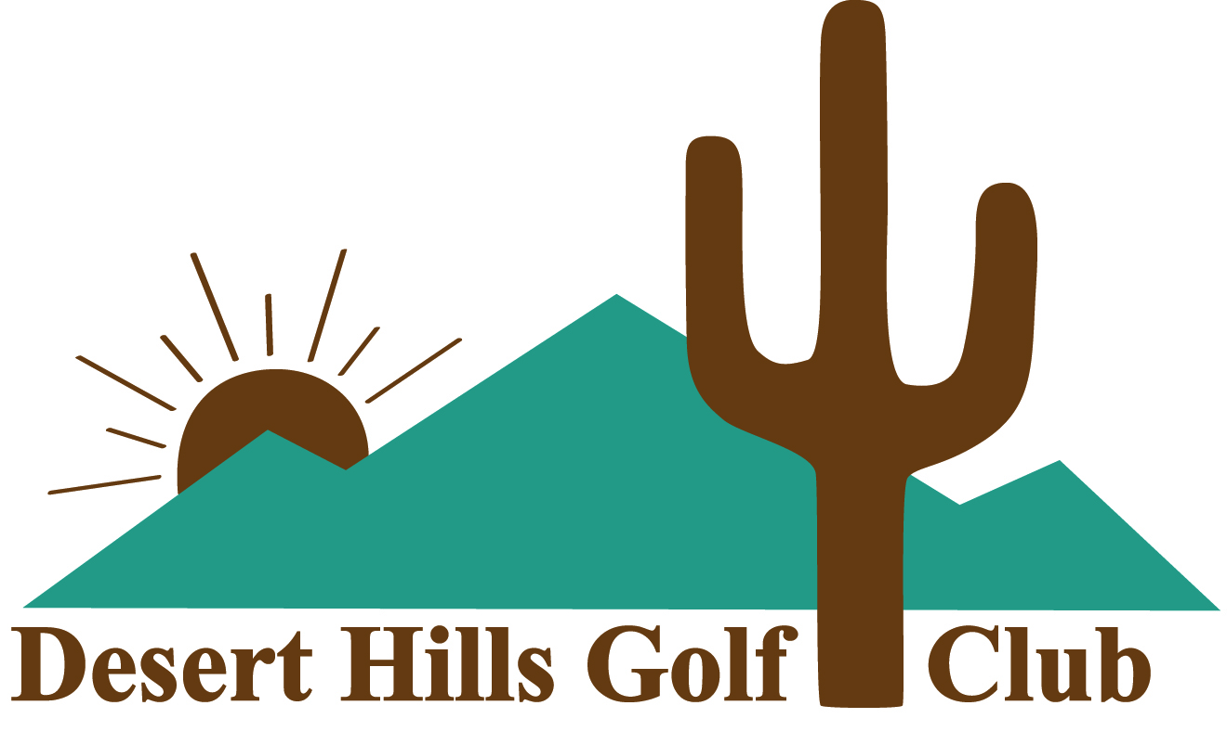
WEEKEND ASSOCIATE MEMBERSHIP
AGES 70 and UNDER

Desert Hills is an exclusive member-owned equity club organized at a 501c(7) non-profit. No Member pays taxes on either the membership certificates or the annual dues.

WAM is a non-equity membership designed for working golfers who want the option of a private club atmosphere while waiting for retirement.

Single Membership $2,540 with 1 cart seat (including sales tax)
Dual Membership $3,560 with 2 cart seats (including sales tax)
Membership runs annually from November 1 through October 31. New members may join at any time, with dues prorated from the date of joining to October 31.

- Board approval of application is required.
- Application for membership is required ($100 application fee).
- The application fee will go towards the cost of the required Equity Certificate if conversion to a Regular Membership occurs by the end of the first year as a WAM.
- This membership may be renewed annually until you reach age 71.
AMENITIES
- Golf Friday after 12:30 pm, and anytime Saturdays, Sundays and Holidays
- Practice facilities and range balls are included
- Walker friendly
- Four hour rounds
- ForeTees online tee time registration
- Option to participate in weekend club-sponsored events with a DHGC established handicap index ($45) paid to the office. Club Championships are excluded.
- Family and Non-family guests allowed at applicated guest fess
- Comfortable lounge with well stocked bar where hot dogs and snacks are available
- Golf Shop features a nice selection of logo clothing, golf bags and shoes

All Memberships are subject to the DHGC Rules and Bylaws
09/2022 Pricing subject to change

