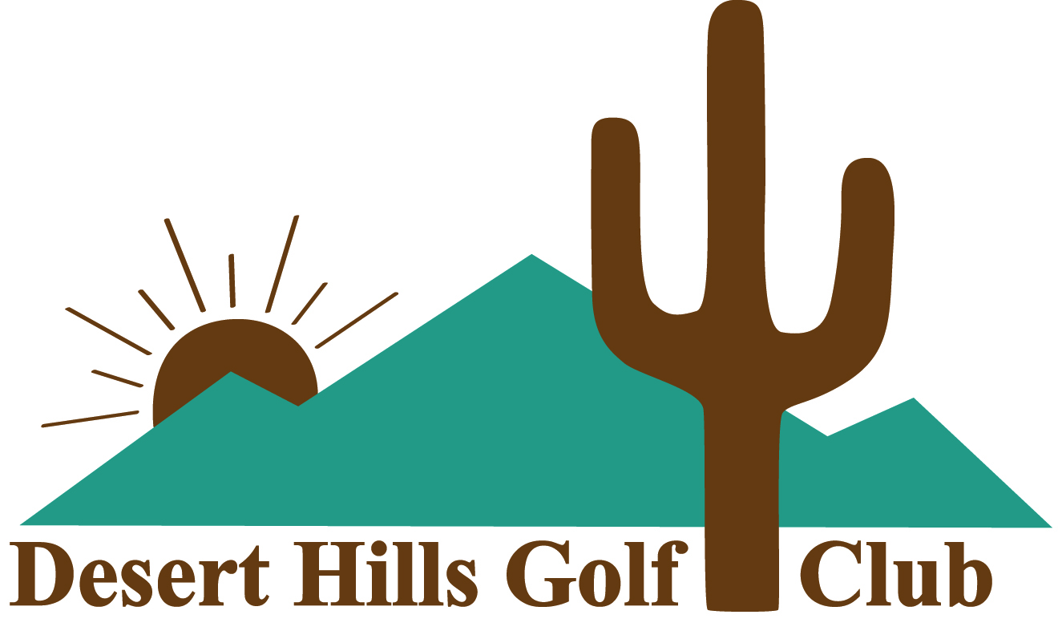

REGULAR MEMBERSHIP

Desert Hills is an exclusive member-owned equity club organized as a 501c(7) non-profit. Regular Members have an equity position, owning a portion of the club along with other Regular Members. No Member pays taxes on either the equity membership certificate or the annual dues.
An application for membership is required ($100 processing fee). Board approval is required as well as a one-time purchase of an Equity Membership Certificate. This cost fluctuates based on demand. Regular Members have full voting rights on club issues. A Regular Membership runs annually from November 1 thru October 31. New members may join at any time. Dues are prorated from the date of joining to October 31.
Annual Dues
Single Membership: $5,310 Annual Cart Seat Rental: $400 (includes tax)
Dual Membership: $7,435 Annual Cart Seat Rental: $800 (includes tax)
AMENITIES
- Unlimited golf 6 days per week (closed Mondays)
- Family and Non-family guests are allowed at applicable rates
- Practice facilities
- Range balls
- Handicap Service
- ForeTees online tee time registration
- Walker friendly
- Four hour rounds
- Wide range of member handicaps allows players to easily find groups to participate
- No restaurant, no minimum spending
- Comfortable lounge with well stocked bar where hot dogs and snacks are available
- Golf Shop features a nice selection of logo clothing, golf bags and shoes
- Many, many social events

All memberships are subject to the DHGC Rules and Bylaws

09/2022 Pricing subject to change

