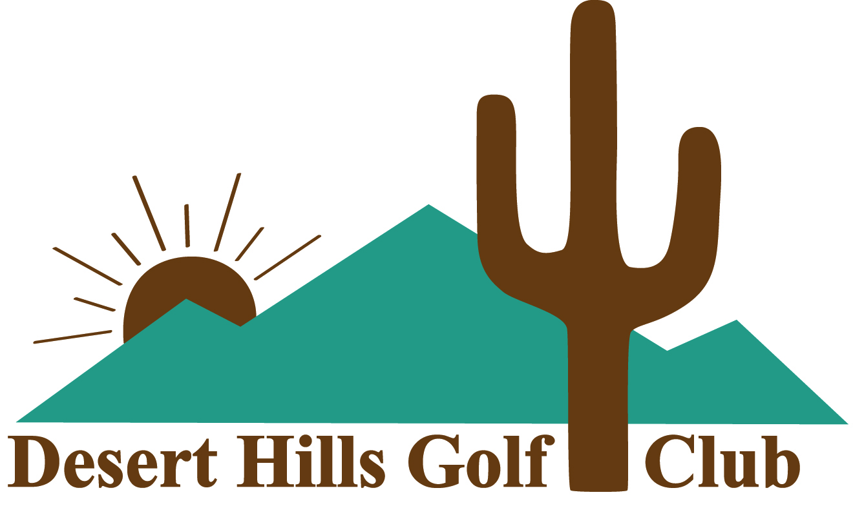

EXECUTIVE ASSOCIATE MEMBERSHIP

Desert Hills is an exclusive member-owned equity club organized as a 501c(7) non-profit. No Member pays taxes on either the equity membership certificate or the annual dues.
This single player non-voting membership is designed for the casual golfer who may not be able to play golf on a regular basis but wants to the enjoy the atmosphere of a private club. This membership is available to new members only. This membership runs annually from November 1 through October 31.
An application for membership is required ($100 application fee). Board approval is required as well. The application fee will be applied to the purchase of a Regular Membership if conversion is by the end of the first year as an EAM.
Cost
- $440 Annual Dues which includes a single cart seat (including tax) AND
- $250 for a non-transferrable certificate for five 18-hole rounds of golf

Fees Apply

- In season November 1st-April 30th $55.00 (includes cart seat) per 18-hole round
- Off season May 1st-October 31st $35.00 (includes cart seat) per 18-hole round
AMENITIES
- Play any day after 12:30 p.m. including holidays. (closed Mondays)
- Tee times available up to three days in advance through the Golf Shop @ (520) 625-5090
- Practice facilities & range balls are included
- Walker friendly
- Four hour rounds
- Family and Non-family guests are allowed at applicable guest rates
- Club-sponsored events not included
- Comfortable lounge with well stocked bar where hot dogs and snacks are available
- Golf Shop features a nice selection of logo clothing, golf bags and shoes

All memberships are subject to the DHGC Rules and Bylaws
09/2022 Pricing subject to change

